**Smart Public Restroom**

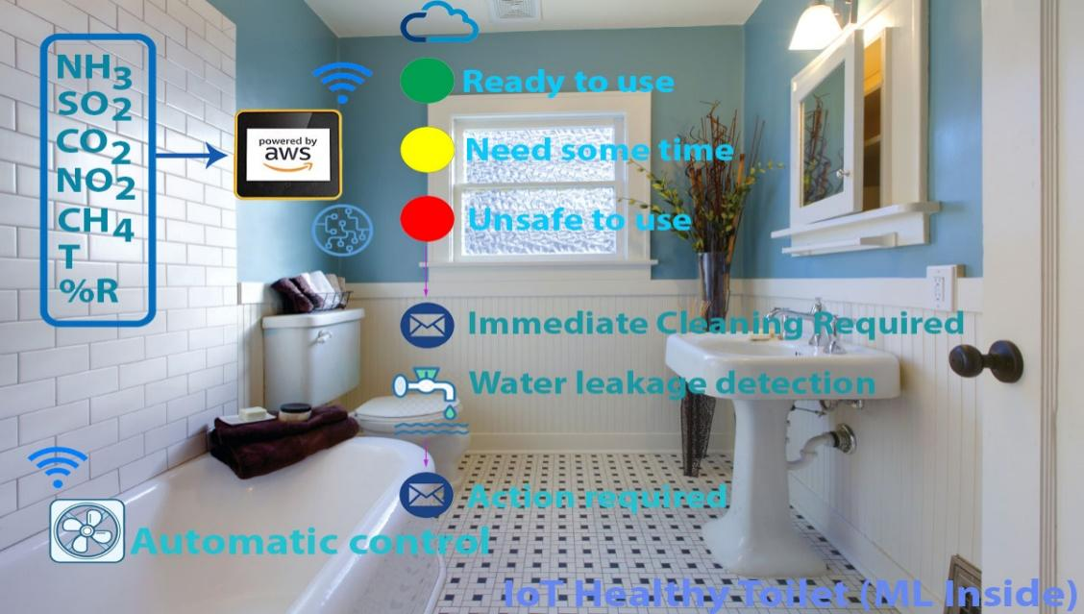

**PROJECT DEFINITION:**

A smart public restroom project involves designing and implementing advanced technologies features to enhance the functionality, hygiene, accessibility and efficiency of public restroom facilities.

This can include dirt detection, smell detection, monitoring the sweeper activity, depth detection . This aims to improve public restroom experiences and contribute to overall urban sanitation and sustainability.

**DESIGN THINKING:**

* In the first phase, IR sensor is used to discover the dirt present in the toilet.
* Here the set of sample images are given as input.
* After using the toilet, the sensor senses the basin of the toilet.
* Then it relates the sensed image with the input image.
* If the dirt present, it increases the alarm.
* Then the user wants to be clean the waste. Through this activity, people can get the awareness about the toilet management.
* In the second phase, Figaro sensor is used to perceive the unwanted gases present in the toilet.
* In the Figaro sensor, a particular range is to be stable earlier manner. If the range gets extended, it can send the alert message to the sweeper. Then they cleaned it by using proper fragrant.
* In the third phase, RFID reader (Radio Frequency Identification) is used to observe the sweeper’s activities (absence and presence in the toilet cleaning).
* Initially, the sweeper wants to show his/her individuality tag in front of RFID reader. It can be shown before and after cleaning the toilet.
* Then the first phase gets initiated and senses for the dirt presence in the toilet.
* If the dirt gets noticed, it raises the alarm.
* Through this monitoring activity, the sweeper can realize their roles and responsibilities. Then they protect the people by disposing all the unwanted materials (dirt, unwanted gases) present in the toilet.
* In the final phase, the sonic sensor is used to detect the depth of the septic tank.
* Here, the range of septic tank is fixed prior manner.
* If the sewage reached with the range, then it directs message to an organization.
* All the message transfer can be done by the GSM (Global System for Communication).

**MICROCONTROLLER:**

* A microcontroller is a small computer on a single combined circuit holding a processor core, memory and programmable input/output peripherals. Program memory in the form of Ferroelectric RAM, NOR flash or OTP ROM is also often included on chip, as well as a typically small amount of RAM. Microcontrollers are designed for embedded applications, in contrast to the microprocessors used in personal computers or other general-purpose applications.

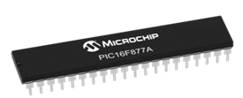

* PIC 16F877 is one of the most advanced microcontroller from Microchip. This controller is commonly used for experimental and modern applications because of its low price, wide range of requests, high quality, and ease of obtainability. It is ideal for applications such as machine control applications, measurement devices, study purpose, and so on. The PIC 16F877 features all the mechanism which present microcontrollers usually have.

**LCD:**

* LCD stands for Liquid Crystal Display. By using the LCD, all the outputs are displayed. LCD doesn’t know about the content (data or commands) supplied to its data bus. It is the user who has to specify whether the content at its data pins are data or commands.

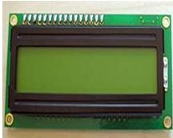

* For this, if a command is inputted then a certain arrangement of 0s and 1s has to be applied to the control lines so as to specify it is a command on the other hand if a data is inputted at the data lines then an another combination of 0s and 1s has to be applied to the control lines to require it is Data.

**SMELL SENSOR:**

* The Smell Sensor is used to detect the unwanted smell and gases in the toilet. For this purpose, we are going to use the sensor called Figaro sensor.

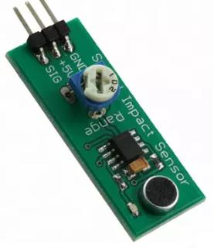

* It can intellect the dry gases present in the toilets such as NH3, CO2, CH4, H2S, etc. By taking those gases leads to Nausea, Drowsiness, instant loss of awareness, etc. After sensing the unwanted gases, it can blink the red light. Then the sweeper can clean it by using particular Cleaning Agents.

**RFID READER:**

* The RFID stands for Radio Frequency identification. It can be used for monitoring the sweeper. The Organization wishes to provide the identity tag for the Sweeper. The Sweeper desires to show the tag before the cleaning process is going to start and after it is finished.

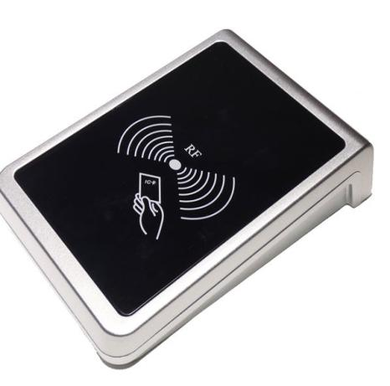

* Then the CR4 sensor can spot the presence of dirt. If it is present, it can blink the red light. If it is clean, it can blink the blue light. It assistances to understand the responsibilities of sweeper by his/her own. If sweeper is not clean the toilets for period of time, his/her absence in cleaning the toilet also reported to the dependable organization. These all the details are stored in the database.

**BLOCK DIAGRAM:**

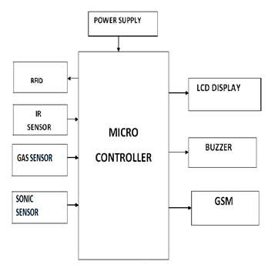

**CONCLUSION:**

* Our proposed project will create awareness among the people about the proper sanitation. It makes use of Internet of things, which is a rapidly growing technology. Our proposed system will make everyone to strictly follow the cleanliness and proper sanitation in the toilets. It prevents the many new contagious diseases that spread due to improper sanitation of the toilets. Thus by using technologies in the smarter way, we can maintain the cleanliness which is next to the godliness. Keep Clean, Be Safe.